URGENT MEDICAL DEVICE CORRECTION
Biofinity Toric Multifocal / Biofinity XR Toric contact lenses
[ABB-CA]
Dear [Name],
CooperVision is voluntarily conducting a recall for certain lots of Biofinity Toric Multifocal / Biofinity XR Toric contact lenses from the USA market, effective immediately.
Our records indicate that you may have purchased a product from the following affected lot(s):

BIOFINITY TORIC MULTIFOCAL 6PK:
Lot # RB0687665
Lot # RB0687693
Lot # RB0687904
Lot # RB0687908
Lot # RB0687910
Lot # RB0687922
Lot # RE0154095
BIOFINITY XR TORIC 6PK:
Lot # RE0154100
Lot # RE0154103
Lot # RE0154105
Lot # RE0154107
Lot # RE0154113
Lot # RE0154114
Lot # RE0154117
COMFILCON A TORIC MFOCAL 1PK:
Lot # RC1768221
Lot # RC1768226
Lot # RC1768273
Lot # RC1768274
Lot # RC1768276
Lot # RC1768281
Lot # RC1768299
Lot # RC1768313
Lot # RC1768314
Lot # RC1768315
Lot # RC1768316
Lot # RC1768319
Lot # RC1768321
Lot # RC1768323
Lot # RC1768327
Lot # RC1768328
COMFILCON A XR TORIC 1PK:
Lot # RD0228465
Lot # RD0228595
Lot # RD0228598
Lot # RD0228603
Lot # RD0228606
Lot # RD0228607

CooperVision internally identified lot(s) that may contain lens blisters (packaging) with an incomplete or leaking seal resulting in a potentially unsterile condition. Consumers who have received Biofinity Toric Multifocal / Biofinity XR Toric lenses from the affected manufacturing lot(s) may experience adverse reactions up to and including ocular infection, should they not detect the seal integrity failure and the lens becomes unsterile prior to use.
There have been no adverse events associated with these lots as of 27 June 2025.
We request you take the following actions:
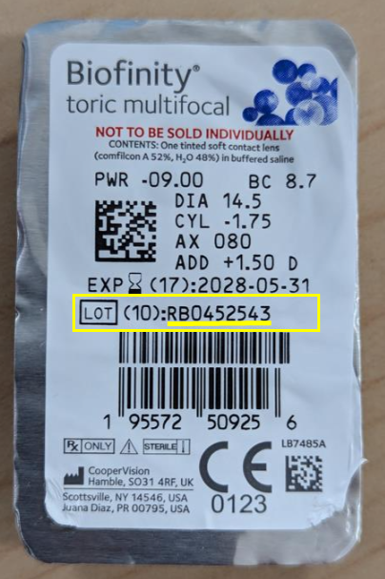
- Please examine any remaining lenses in your possession. The lot number can be found on the back panel of the carton below the expiration date, or on the front of the blister label below the expiration date. Below is an example of where to locate the lot number on a carton or blister.
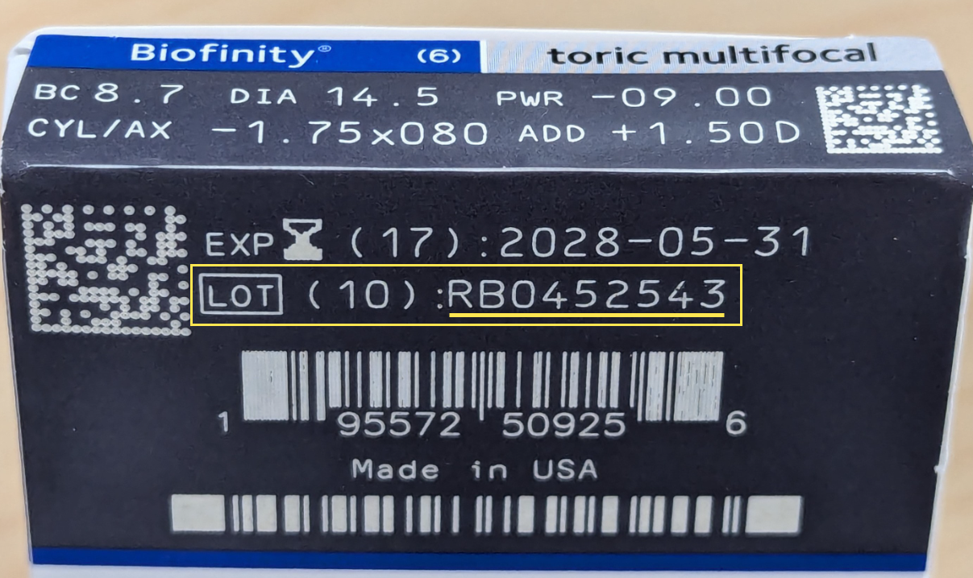

- If you locate any of the affected product, we recommend you return the affected product to our office at the address below for credit and/or replacement.
- Adverse reactions or quality problems experienced with the use of this product may be reported to the FDA’s MedWatch Adverse Event Reporting Program, either online, by regular mail, or by fax.]
- [ECP Office Information]
We apologize for any inconvenience. Should you wish to discuss this action, please contact the CooperVision Customer Care Team at 855-526-6737, 9:00 AM – 5:00 PM ET, Monday – Friday.
Yours sincerely,

Eye Care Practitioner

